Sebastien Samedy   
Znumber: 23688506  
GitHub username: Sebastien100  
GitHub repository: https://github.com/CEN4010-Fall2023-Prin-Soft-Eng/hw1-Sebastien100.git  
9/20/2023   
8:18 PM  
  
**Objective 1**   
  
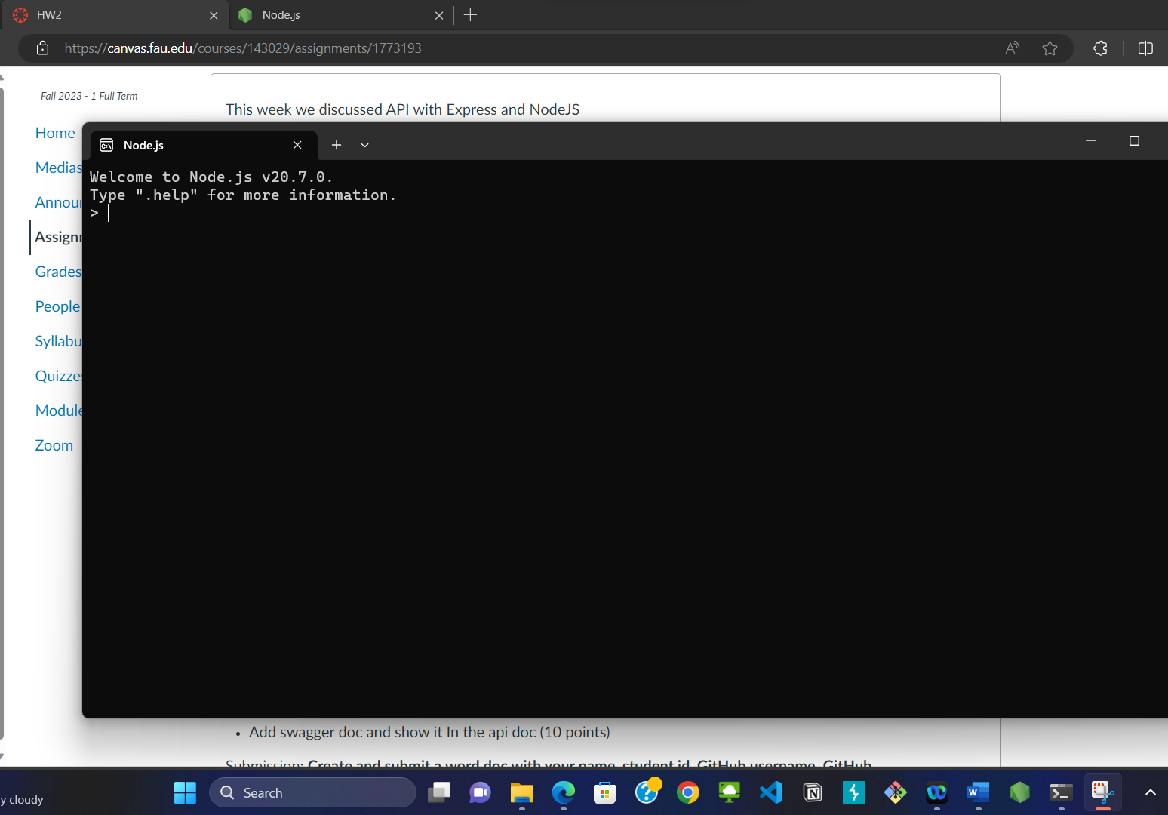  
  
  
**Objective 2:**

clone repo  
  
npm install/ start  
  
npm install nodemon  
  
  
load home page  
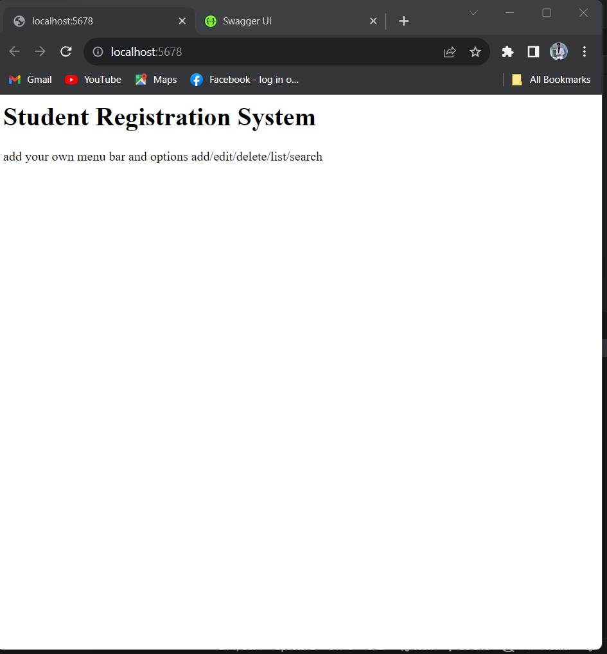  
  
load the api doc  
The command nmp start provides two links to open the home page and load the api doc page.  
  
  
 **Objective 3:**Using postman and Swagger UI I am able to POST: create a new student, PUT: update a student ID, DELETE: delete a student by ID, GET: display a single student by ID, GET: list all students. POST CREATE NEW STUDENT  
  
PUT UPDATE A STUDENT BY ID  
  
DELETE A STUDENT BY ID  
  
GET DISPLAY SINGLE ID  
  
GET LIST ALL STUDENTS  
  
**Objective 4:**Followed the recording and rewatched to get a better understanding of objective 4GET searching for student by last name  
  
  
ADD swagger doc and show it in the api  
